**Methodology**

**Property Price Index**

**2019=100**

**Contents**

|  |  |
| --- | --- |
| 3 | General background on the Property Price Index |
| 4 | Target community and framework |
| 7 | Project sample |
| 7 | Work stages of the project |
| 9 | Data preparation stage |
| 10 | Property Price Index Calculation |
| 12 | Dissemination tables |
| 13 | Definitions |
| 14 | Improvement plan |

**First: General background on the property price index**

**Introduction**

Real estate plays an important role in the sustainable development organization in the Emirate of Dubai, as it is a strategic production factor for all vital sectors. It is also an important field for productive investment that generates income and provides job opportunities, and is the basis for launching investment projects in various economic and social fields .

Therefore, there was great care to follow up on the price movements of the units that make up the property sector and to monitor the values of their transactions in the various sectors and regions of the emirate, and to follow up on the changes that occur to them from time to time through the property price index program that was prepared based on the data provided by Dubai Land Department in this field, within the framework of cooperation and integration between various government agencies aiming to drive sustainable development in the emirate .

The property price index aims to create distinct property statistical indicators that measure the performance of the property market in the emirate and fill the data gap in this sector. It is also considered an important tool to support the parties concerned with making economic decisions related to this matter, and its data is useful to those interested in economic and statistical analyses of property price movements and future forecasts during different time periods .

Property Price Index is built on the basis of databases available for the Emirate of Dubai which contain detailed information on all property transactions registered and sold at the emirate level.

This is the first national experience and one of the pioneering projects of the UAE. It aims to improve the transparency and functioning of the property market in the emirate. In addition to analyzing inflationary and recessionary risks and monitoring property risks in the banking system. However, building such a tool faces many difficulties related mainly to the nature of this asset. Indeed, the property market shows great heterogeneity, which makes adopting a systematic approach extremely difficult because the prices of different properties are affected by intrinsic characteristics such as area, number of rooms, age of the building and geographical location. Also property represents a permanent asset that rarely changes its owner, which makes assessing price fluctuations difficult .

In order to reduce the impact of the above-mentioned limitations and depending on the nature and availability of databases, the data available at the emirate level, as well as the tests and treatments applied, and the methodology adopted in constructing the index, are presented and discussed.

**Property Price Index Objectives**

property price index is considered one of the most important indices, which statistical centers are keen to issue. Therefore, the objectives of the property price index and the importance of its uses can be summarized as follows:

* Real estate price indices are accurate statistical indicators that are reliable for measuring the performance of the property market
* The real estate price index is also widely used as an indicator of inflation and economic recession trends and as an alternative to the general index of inflation in the economy due to its recent production.
* Meeting the national and international requirements and needs of researchers and scholars in the field of property research
* It is used in national accounts as a reliable indicator in estimating and extracting the impact of price changes in the property sector on the gross domestic product of this sector.

**Second: Target community and project framework**

**Target community**

Detailed data on property sale prices is based on the Tabu database, which is a primary source of data. It includes details of property sale prices in AED. And the area in square meters .

Property price statistics in the Emirate of Dubai adopt the approved classification according to which the prices of real estate unit sales are recorded.

**The data included property sales prices according to the classification approved by the Dubai Land Department as follows :**

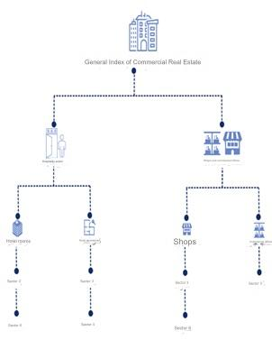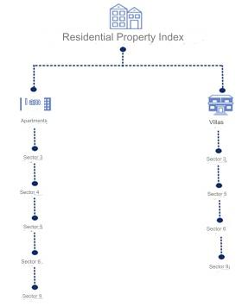

**Identify data sources**

When working on the Property Price Index project, a quarterly and annual index covering cash transactions was targeted for all types of property in line with the concepts defined in this methodology.In order to model a property price index that is consistent with recommended best practice data on transaction prices as well as key characteristics of residential and commercial properties , a consistent quality index is required. As with any price index, the aim is to track price trends by comparing similar properties . This is a challenge since direct price comparison requires similar properties to be transacted in successive periods , To obtain a high-quality property price index depends largely on obtaining detailed information about each property.

**Source data quality assessment**

Before creating a property price index and selecting data sources, we Conduct a comprehensive data quality assessment. The data source is evaluated using a quality assessment framework. The data is assessed for accuracy, fitness for purpose, structure, coverage, and availability.

* Accuracy can be determined by assessing missing values ​​and outliers
* Fitness for purpose is related to whether coverage is adequate or meets the required timeliness and periodicity (quarterly, annually)
* Data structure can be measured by the number of variables or attributes associated with each property sale
* Coverage check, for example, if the target is an emirate index but the data source only includes transactions for two of the top 10 areas, coverage will be low
* Assess data availability and quality. Examples of challenges associated with data availability include:
* Dealing with different formats
* Various variables
* Variants with the same name but different meanings
* No common key to merge information

**Select base period**

The year in which the weights are calculated may often coincide with the chosen base year. The base year may be changed from time to time in accordance with adjustments to the weights, and it is necessary to prepare a time series of data that is continuous despite the adjustments to the base year.

According to the methodology used, shadow prices are used as a base price and with different characteristics, the hedonic regression methodology allows the analysis of the price of each property. According to its constituent characteristics. The table below shows an example of shade prices for residential units according to specifications.

|  |  |  |
| --- | --- | --- |
| **Characteristics** | **House A Shadow Prices** | **House B Shadow Prices** |
| **Size** | 350,000 | 350,000 |
| **Bathrooms** | 45,000 | 30,000 |
| **Garage** | 20,000 | 20,000 |
| **Balcony** | 10,000 |  |
| **Total** | 425,000 | 400,000 |

To enable slopes In order to reliably estimate the coefficients for each of the variables included, there must be sufficient depth in the data set at the level of each of the variables , This is known as "degrees of freedom" in statistics.

**Setting up weights**

Weights play an important role in compiling price indices . Weights are used to aggregate prices from the basic level into more significant aggregates and groups .

Weights are calculated according to the nature of the data available on the types of properties according to the different regions, and the weights are calculated in the following manner:

* According to property transactions: Relying on the value of the total property transactions that took place for the types of property and the sectors represented in the index during the year chosen to be the base year .

The weights of property transactions were relied upon in this project for the purposes of measuring the flow to monitor financial stability in the Emirate of Dubai.

The flow weights are calculated using transaction data to aggregate the layer indices to the top level. The weights are updated annually with transaction data for the previous year, or the previous three years while keeping them constant for the year (Laspeyres type index).

**Sample frame​**

property units that will be used to calculate the property price index from the Tabu database are determined through models built on the R program, and the basic fields for selecting the terms are calculated and displayed . *The process of creating the base basket (shadow prices) is done directly through the registry databases in the model so that all data in the database* (property *framework according to regions) is targeted for the specified year.*

**Third: Project sample**

**Sample unit withdrawal**

the project is selected based on the registered data, taking into account the coverage of all the properties represented according to the classification approved by Dubai Land Department at the level of the Emirate of Dubai, as the aim of the project is to provide comprehensive coverage of Property prices included in the calculation of the property price index data for the year 2019 was chosen as the base year for the property price index.

**Fourth: Work stages of the project**

The project work phases included a set of overlapping and integrated operations carried out by the work team based on the stages of the statistical operations governance and management methodology to prepare the work plan and the timetable for its implementation and to ensure that the work is completed within the highest quality standards . They included the following:

**Design phase**

This stage included preparing and reviewing the data received from Dubai Land Department, it also included the sample design and methodology, preparation of a description of variables, design and approval of matching rules, auditing, review and methodologies for processing data and outputs for statistical systems.

**Building phase**

This stage includes the development, design and approval of systems for the process of uploading, reviewing and processing values and calculating the price index. Residential and commercial propertydesign and construction of reporting tables for statistical systems .

**Data preparation stage**

Dubai Land Department provides property data for the Emirate of Dubai on property sale prices, where this data is processed, classified, and published according to the classification approved by Dubai Land Department. The foundations have been laid for constructing the real estate price index and developing appropriate solutions to the problems that may face calculating real estate prices by adopting more than one method for analyzing real estate sale prices, which have been fully automated within the R program models.

**Data Processing Phase**

The data processing stage includes classifying and coding variables, applying auditing, reviewing and checking rules to the data, approving raw data, compensating for missing values, calculating weights, calculating aggregate results from main and sub-data, and approving the pre-final database .

**Analysis phase**

This stage includes extracting the initial results, calculating the initial indicators, comprehensive auditing of the results and comparison with previous statistics and verification of other available data, analysis of the results, reviewing the results and applying their confidentiality levels , reviewing the results and applying their confidentiality levels , approving the final results, reviewing and approving the final results, and coordinating with external stakeholders to approve the final results. In this stage , the general methodology and work methods used are documented and approved.

**Dissemination phase**

This stage includes ensuring the designs of all outputs and their suitability for publication coordinating with stakeholders to agree on the results that are authorized for publication and determining the levels of publication, reviewing and approving the levels of publication, and building statistical packages and reports. This stage is concerned with publishing data on the packages that were designed in the construction stage, and includes publishing reports and statistical releases electronically , as well as limiting news and providing the media with them , and managing the social media channels for statistics . It also includes receiving and delivering requests from various concerned groups, and communicating with clients to respond to their inquiries after the completion of the publication of the data.

**Evaluation phase**

At this stage, which comes at the end of the project, the statistical process is evaluated in coordination with the internal and relevant parties , and an improvement plan is developed in coordination with the relevant internal parties and approved .

**Fifth : Data preparation stage**

**Data preparation**

Property price data is available for the Emirate of Dubai, where this data is processed, classified and published according to the classification adopted in the Emirate of Dubai.

The foundations for constructing the Property price index have been laid and appropriate solutions have been developed for the problems that may face the calculation of the property price index by adopting more than one method for analyzing property price data.

The most important problems that may face the calculation of property price indices in terms of accuracy, suitability for purpose, structure, coverage and availability are as follows:

* *Accuracy : Errors and missing data*
* *Fitness for purpose : Conceptual issues such as whether the price reflects the target price concept, whether coverage is adequate, or whether it meets the required timing and frequency requirements (monthly, quarterly, annual).*
* *Data structure : The number of variables or attributes associated with each variable .*
* *Coverage : Geography, property types , transaction type, types of sellers and/or buyers*
* The absence or loss of property unit prices according to the type of property, type of use, sector, and geographical areas, in accordance with property transactions that take place at the emirate level*.*
* Heterogeneity​ Specifications of the property units sold , which leads to price fluctuations and the impact of the index number

**Automated Auditing**

* Data cleaning, data analysis, and data preparation for processing and modeling. The following steps were developed for data cleaning:
* Remove duplicates
* Remove transactions with missing values
* Identify and remove outliers
* Bedroom Classifications

Analysis was performed and outliers were detected . outlier's detection for each month using price per square meter. Different options for outliers should be tried by changing the value of interquartile multiplier

**Sixth: Calculating the property price index**

To measure net price changes, it is necessary to measure the same product over time taking into account changes in its quality and quantity . In the property price index, the treatment of quality requires detailed information about the characteristics of the units, which can be done using the hedonistic regression method .

regression method takes into account the description of heterogeneous goods through their properties. That is, a good is essentially a bundle of specifications . In the property field , this bundle may include the properties and location of the property . These properties are not sold separately, and therefore their prices cannot be observed independently in the selling price . Although these prices are not observed, they can be estimated using hedonic regression techniques, and these prices are often referred to as "shadow" prices .

Time Dummy Hedonic Method is generally used when a large number of characteristics are available for the data but the number of coefficients in the time period to be measured is small . Using this method, prices and characteristics ($Z_{nk}^{t}$) of all housing units (n) are pooled for several periods (t) in the same regression and a variable is estimated for each period ($D_{n}^{t}$). The index is based directly on the estimated time dummy parameters.

The log-linear specification is used, so the regression model is :

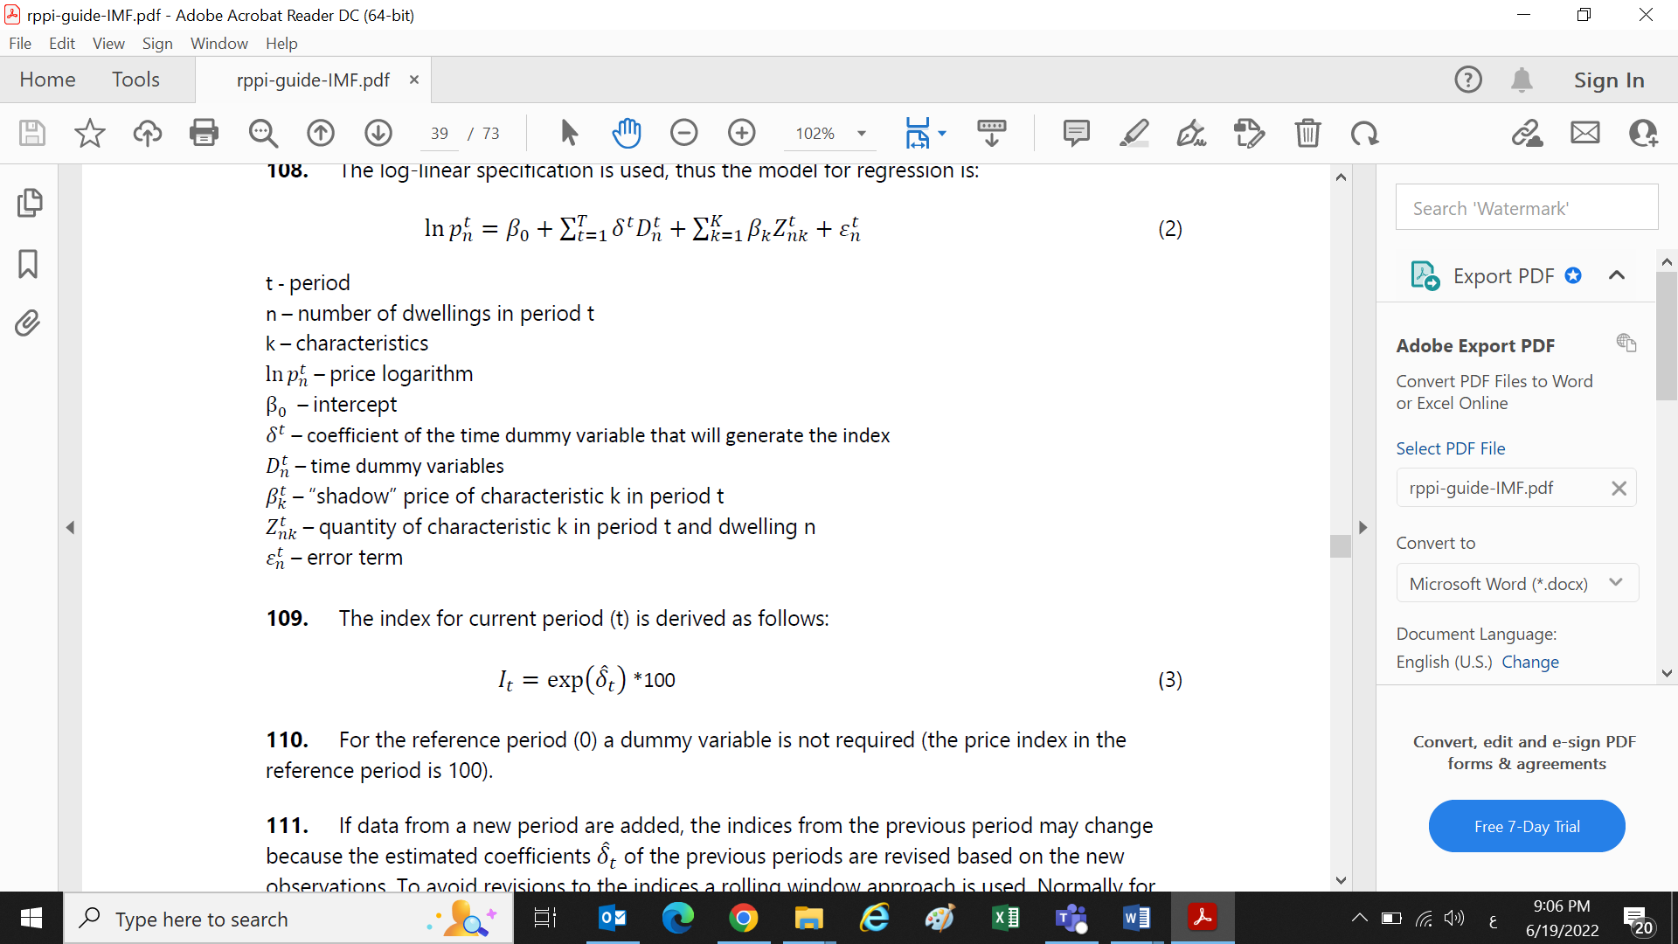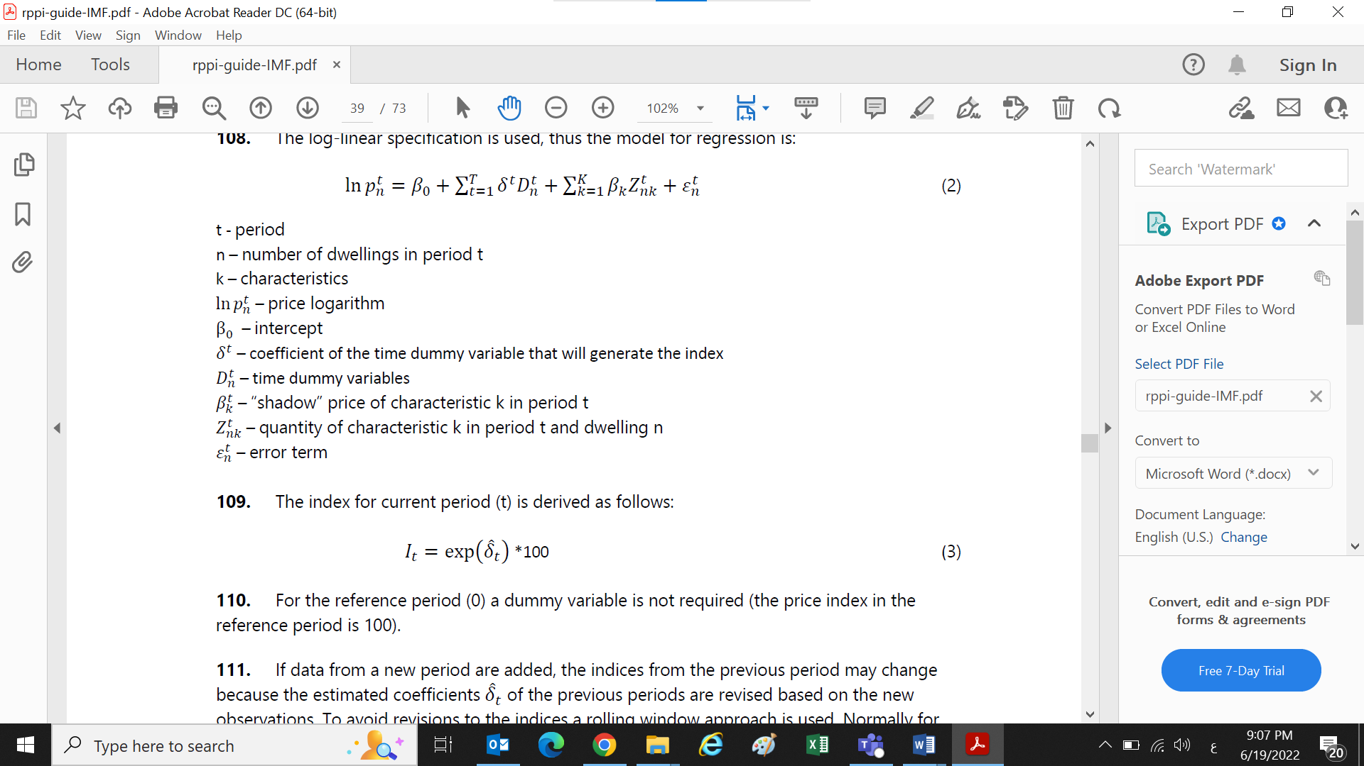

The current period (t) index is derived as follows:

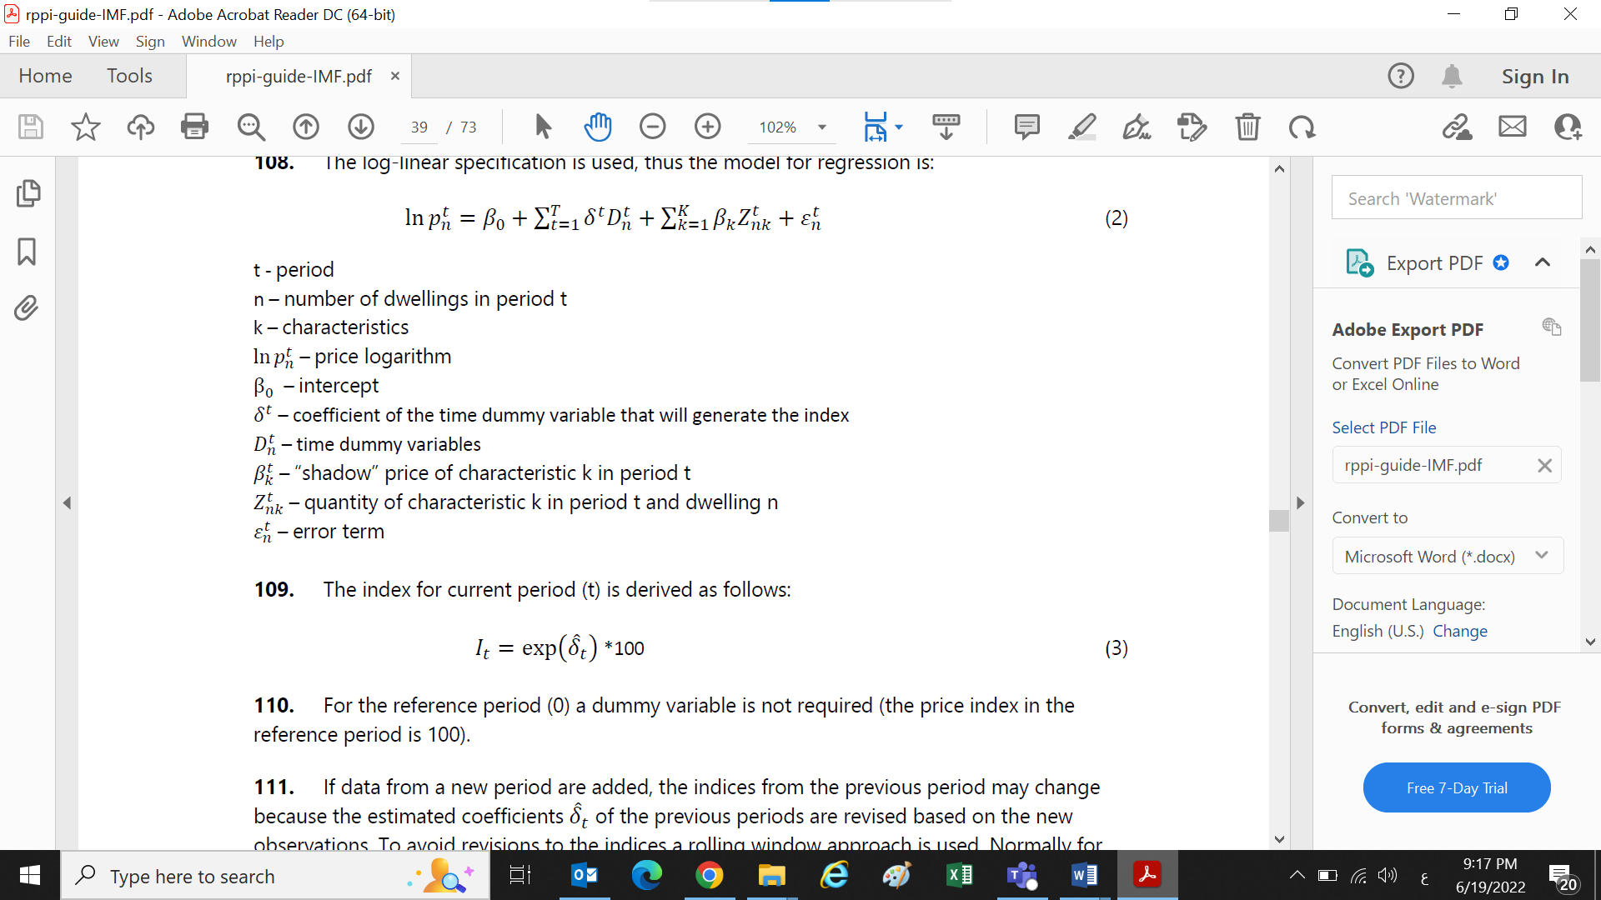

For the reference period (0), no estimates of the variables are required (the price index in the reference period is 100).

If data is added for a new period, the indicators for the previous period may change. Because the estimated transactions $δ^{t}$ For previous periods they are revised based on new observations . To avoid adjustment to the indices, a rolling window approach is used . For quarterly indices , the “shadow” prices of the properties are held constant for at least one year. This means that data from 12 months are used together , Each quarter , the regression is estimated with data from the current quarter and the previous three quarters . The indicators from the new 12-month window and the previous 12-month window are linked using the last overlap period between the two windows .

**Seventh: Dissemination tables**

**Extract results**

The R program model provides statistical reports for the property price index at the quarterly and annual levels, including the following reports:

* Property Price Index Residential /Commercial))
* Quarterly percentage change for property price indices residential /commercial))
* Annual percentage change in property price indices residential /commercial))

**Display and publish results**

After extracting the results, once the indices have been calculated, they are displayed in special tables and graphs, noting that the process of publishing the data must be done in accordance with the controls that have been agreed upon in the levels of confidentiality, taking into consideration specific standards and controls, which are as follows:

* Data confidentiality controls
* Specific controls on the limit to which it is published
* Controls specific to international publishing standards

Property price index residential /commercial) ) are displayed through:

* Property price index report (residential/commercial) in Dubai Data and Statistics Establishment website and Dubai Land Department Website.
* Periodic press releases that review the most important results of the project.

**Data review**

Corrections are made when corrected or revised information is applied to calculate the Property Price Index (residential/commercial).

**Eighth: Main definitions**

The definitions and classifications used were prepared based on international standards issued by the United Nations and some of its specialized agencies and according to what is statistically accepted.

**Property Price Index:**

A statistical tool to measure the relative change in property prices. Between two time periods .

**Property:**

A fixed capital asset that cannot be moved without damage, such as land and buildings.

**Base period :**

The time period that is compared to the current period. The base period is determined according to the available data, taking into account the necessity of it being a year characterized by economic stability, and free from abnormal price fluctuations.

**Base period prices:**

The prices of goods and services to which the current prices are compared.

**Weights (relative importance):**

It represents the relative importance, and is used in mathematical operations to calculate the index.

**Source:**

Data source that owns records

**Hedonic regression method:**

Is a statistical technique used to estimate the value of goods that heterogeneous goods can be described by their attributes or characteristics.

**Laspeyres equation:**

It is a mathematical equation developed by the statistician Laspeyres to calculate price indices by dividing the prices of the comparison year by the prices of the base year, and by weighting the quantities of the base year.

**Price index:**

The index is defined as a relative number that measures the change in the prices of a group of goods and services, and is obtained by the ratio of the prices of goods and services in the comparison period to their prices in the base period.

**Program:**

R program (models) used to calculate the property price index.

**Ninth : Improvement plans**

* Expanding the use of Dummy variables
* Follow up on updating internationally approved methodologies and classifications
* Applying the methodology of digitizing data processing and analysis to the sources of historical data to calculate the indices
* Opening communication channels with Dubai Land Department to display the results and discuss the mechanism for publishing and approving the results.